ON MY PART 2 THERE’S NO FEEDBACK ,THIS ARE THE CHANGES I MPLEMENTED FROM THE THE PREVIOUS PART

Automation of Features

* Implemented an auto-calculation feature to compute the final payment based on the hours worked and hourly rate reported by the lecturer.
* Developed functionality to automatically generate invoices or reports based on the claim data.
* Implemented features for managing lecturer data, such as updating personal information or contact details.
* Integrated tools like ASP.NET Identity to handle user authentication and authorization.

Tools Used

* Leverage ASP.NET Core Web APIs to handle communication between the front-end and back-end systems.
* Utilized the Entity Framework Core to interact with the database and perform data operations.
* incorporated the Crystal Reports or SQL Server Reporting Services libraries to generate the required reports.

Key Features

* Expanded the automated claim submission process to include additional validation checks and business rules.
* Implemented a tracking system that updates the status of each claim as it moves through the approval process.
* Developed the report generation functionality to allow for customizable date ranges and filtering options.
* Ensured the system provides consistent and reliable information through error handling and exception management.

Submit new claim and your claims

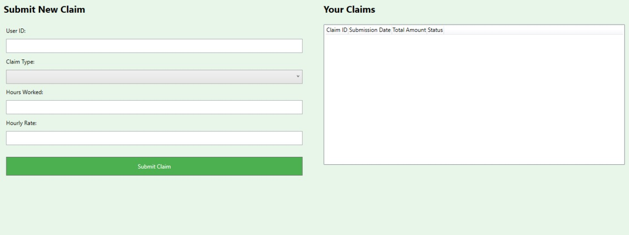

User information and user list

Pending claims for approval

<https://github.com/ST10386008/CMCS.git>